**TITLE PAGE CONTENT**

**NAME OF SYSTEM**

Freelancing Tourism Guidance

**DATE**

1.0

**Presented To:**

Tourists - Tour Guides

**Submitted By:**

Bahaa Zenhom

**REVISION HISTORY**

| **Date** | **Author** | **Distributed to** | **Version** | **Description** |
| --- | --- | --- | --- | --- |
| DD\ MM\YYYY | name | who | Matches title page | Brief description of change |

**TABLE OF CONTENTS**

1. **PRODUCT DESCRIPTION**

The project is a mobile app system, it will be a freelancing platform for both the tourists and the tour guides, the main goal of the project is to deliver both sides with each other in an easy, quickly, and professional way. The project is mainly based on the needs of tourists for small or custom trip guidance in an easy quick way, and also the needs of tour guides to get flexible small daily jobs according to his business or his main work. The project aims to serve the tourists be providing tourism services he can choose from which will him comfortable with his trip, also provides a new market for those tour guides who don’t have a stable work or want to work in specific times of the week. The main functions of the project will differ according to who’s the user, for the tour guide he can post his services that he can provide to the tourist with all the details and excellence that he will provide to the tourists who want to take this service, also the tour guide will have the ability to explore the tourists custom services which they have posted and offer proposals and negotiate on this services, from the other side there will be the tourist who will have the ability the explore tour guide’s services and choose a suitable one for him, or just post a custom one to start receiving proposals on it, also he will have the ability to explore the most famous tourism places around him, there will be also a chat system make them communicate with each other.

1. **TEAM DESCRIPTION**

|  |  |
| --- | --- |
| **Name** | **Position & Skills** |
| Bahaa Zenhom | Responsible for the documentation, system design, database design, and the UI UX of the project |
| Youssef Gamal | Responsible for the backend side using .Net framework - Database |
| Moustafa Gamal | Responsible for the backend side using .Net framework - Database |
| Arwa Ashraf | Responsible for the frontend side and APIs using Flutter framework |
| Ahmed Hofny | Responsible for the frontend side and APIs using Flutter framework |

**3. SOFTWARE PROCESS MODEL DESCRIPTION**

We will be working with Agile process model, due to its flexibility and the process that it runs with, as we don’t have all the requirements of the project and don’t have any experience working on a project with a team, then Agile is the most suitable process model for us.

**4. PRODUCT DEFINITION**

**Context Diagram**

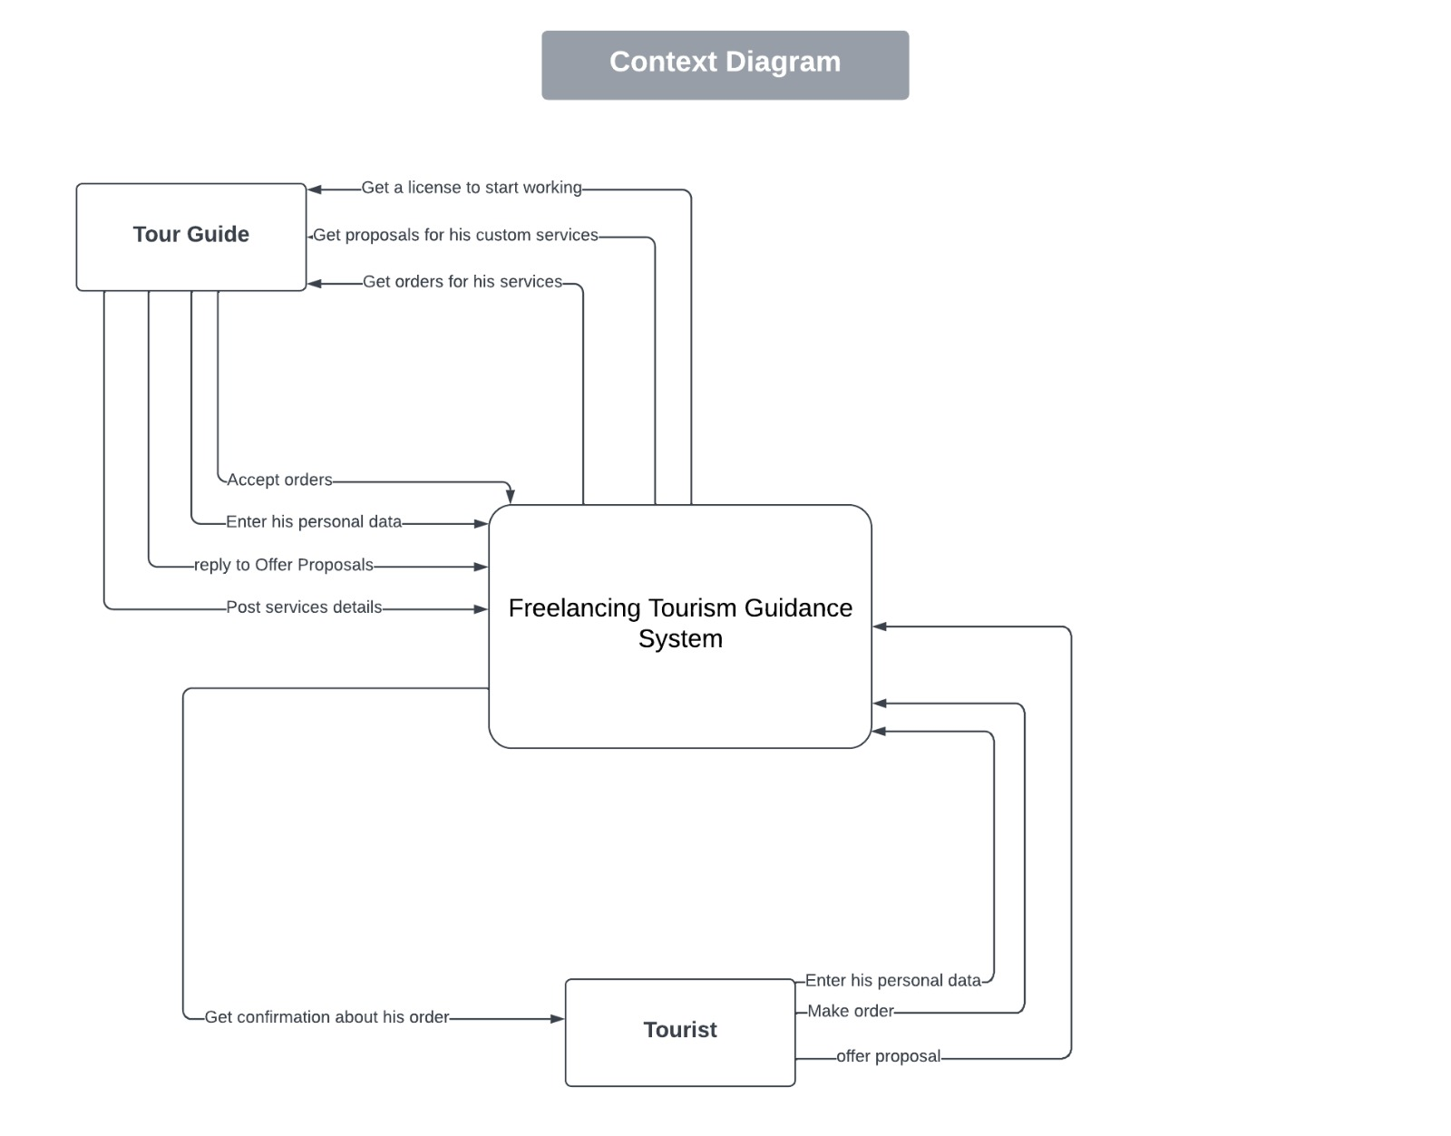

**Personas**

**Tourists:**

The tourists are users who is looking for a customized trip guidance service. They may have specific interests, preferences or requirements for their trip, the tourists should be familiar with using mobile devices.

Name: Sarah

Background: Sarah is a 30-year-old traveler who enjoys exploring new places and cultures. She works as a freelance writer and has a flexible schedule, which allows her to travel frequently. She prefers customized tours that cater to her interests and hobbies.

Goals: Sarah's primary goal is to find a reliable and professional tour guide who can provide her with a personalized tour experience. She wants to explore the famous tourist attractions and landmarks, but also discover the hidden gems that are not typically included in mainstream travel guides.

Challenges: Sarah faces several challenges in finding the right tour guide for her needs. She is often overwhelmed by the sheer number of options available online, and she struggles to differentiate between the different levels of quality and professionalism. Additionally, she wants to ensure that the tour guide is knowledgeable, trustworthy, and able to communicate in her language.

How our app can help: Our app can help Sarah by providing her with a user-friendly interface that allows her to browse and compare different tour guides and their services. The app should offer clear descriptions of each tour guide's experience, qualifications, and specialties, as well as reviews and ratings from previous customers. The app should also provide a messaging feature that allows Sarah to communicate directly with potential tour guides and ask any questions she may have before booking a tour. Finally, the app should make the booking process as seamless and secure as possible, with clear pricing information and payment options.

**Tour Guide:**

The tour guide is a key user who provides services to tourists through your platform.

Name: Ahmed

Background: Ahmed is a licensed tour guide who has been working in the tourism industry for over 10 years. He has extensive knowledge about historical sites and famous tourist attractions in his country. However, he currently faces challenges in finding steady work that fits his schedule, as well as reaching new clients who are interested in his services.

Motivations: Ahmed wants to use your platform to increase his visibility and connect with tourists who need his services. He is looking for a flexible way to find daily jobs according to his schedule, as well as build his reputation through positive reviews and ratings from satisfied customers.

Goals: Ahmed's primary goal is to post his services on your platform and receive orders from tourists who are interested in his expertise. He also wants to be able to negotiate with tourists and make proposals on their custom service requests. Additionally, he aims to build his reputation through positive feedback and ratings, which will lead to more business in the future.

Pain points: Ahmed faces challenges in finding steady work that fits his schedule and meeting new clients who are interested in his services. He also worries about getting negative feedback or ratings, which could hurt his reputation on the platform. Finally, he wants to ensure that the platform provides a secure and reliable way to receive payment for his services.

**Ministry of tourism:**

The Ministry of Tourism is an external actor that interacts with the system. the Ministry of Tourism is responsible for verifying the credentials of tour guides who wish to register on the platform. They will receive personal work data of tour guides from the system as input, and their output will be a confirmation whether the tour guide is licensed or not.

**User Stories**

For Tourists:

* As a tourist, I want to be able to search for available tour guides based on my location and the type of service I need.
* As a tourist, I want to be able to view tour guide profiles and read reviews from previous clients.
* As a tourist, I want to be able to book a tour guide and pay for their services through the app.
* As a tourist, I want to be able to communicate with my tour guide through the app to ask questions or provide feedback.
* As a tourist, I want to be able to rate and review my tour guide after the tour is finished.
* As a tourist, I want to be able to browse through a list of popular tourist destinations and get information about each one.

For Tour Guides:

* As a tour guide, I want to be able to create a profile that showcases my skills and experience.
* As a tour guide, I want to be able to post the services I offer and set my availability and pricing.
* As a tour guide, I want to be able to receive requests from potential clients and negotiate the details of the service.
* As a tour guide, I want to be able to communicate with my clients through the app to answer their questions and provide information.
* As a tour guide, I want to be able to receive payment for my services through the app.
* As a tour guide, I want to be able to view ratings and reviews from previous clients to improve my services.

For Ministry of Tourism:

* As the Ministry of Tourism, I want to be able to verify the licenses and credentials of tour guides who use the app to provide services to tourists.
* As the Ministry of Tourism, I want to be able to access information about the number of tours provided and the satisfaction of tourists using the app.

**Requirements**

**Functional Requirements:**

1. User Registration: Users should be able to create an account and register on the platform.

2.User Authentication: Users should be able to log in securely using their credentials.

1. Tour Guide Listings: Tour guides should be able to create listings for their services, including details and availability.
2. Booking Management: Tourists should be able to browse and book tour guide services based on their preferences.
3. Proposal System: Tourists should be able to send proposals to tour guides, including desired services and negotiated prices.
4. Payment Integration: The platform should integrate with a secure payment gateway for processing transactions.
5. GPS Integration: The application should utilize GPS services to provide navigation and location information to users.
6. Review and Rating System: Users should be able to rate and review tour guides based on their experiences.
7. Admin Dashboard: An administrative dashboard should be available to manage user accounts, listings, and overall platform operations.

**Nonfunctional Requirements:**

1. Usability: The application should have an intuitive and user-friendly interface.
2. Performance: The system should handle a large number of users and transactions without significant delays.
3. Security: User data and payment information should be stored and transmitted securely.
4. Reliability: The platform should be available and operational with minimal downtime.
5. Scalability: The system should be able to accommodate a growing number of users and listings.
6. Mobile Responsiveness: The application should be accessible and functional across various mobile devices.
7. Language Support: The platform should support multiple languages to cater to a diverse user base.
8. Data Backup and Recovery: Regular backups of user and system data should be performed, with provisions for data recovery in case of failures.

**High Level Use Cases**

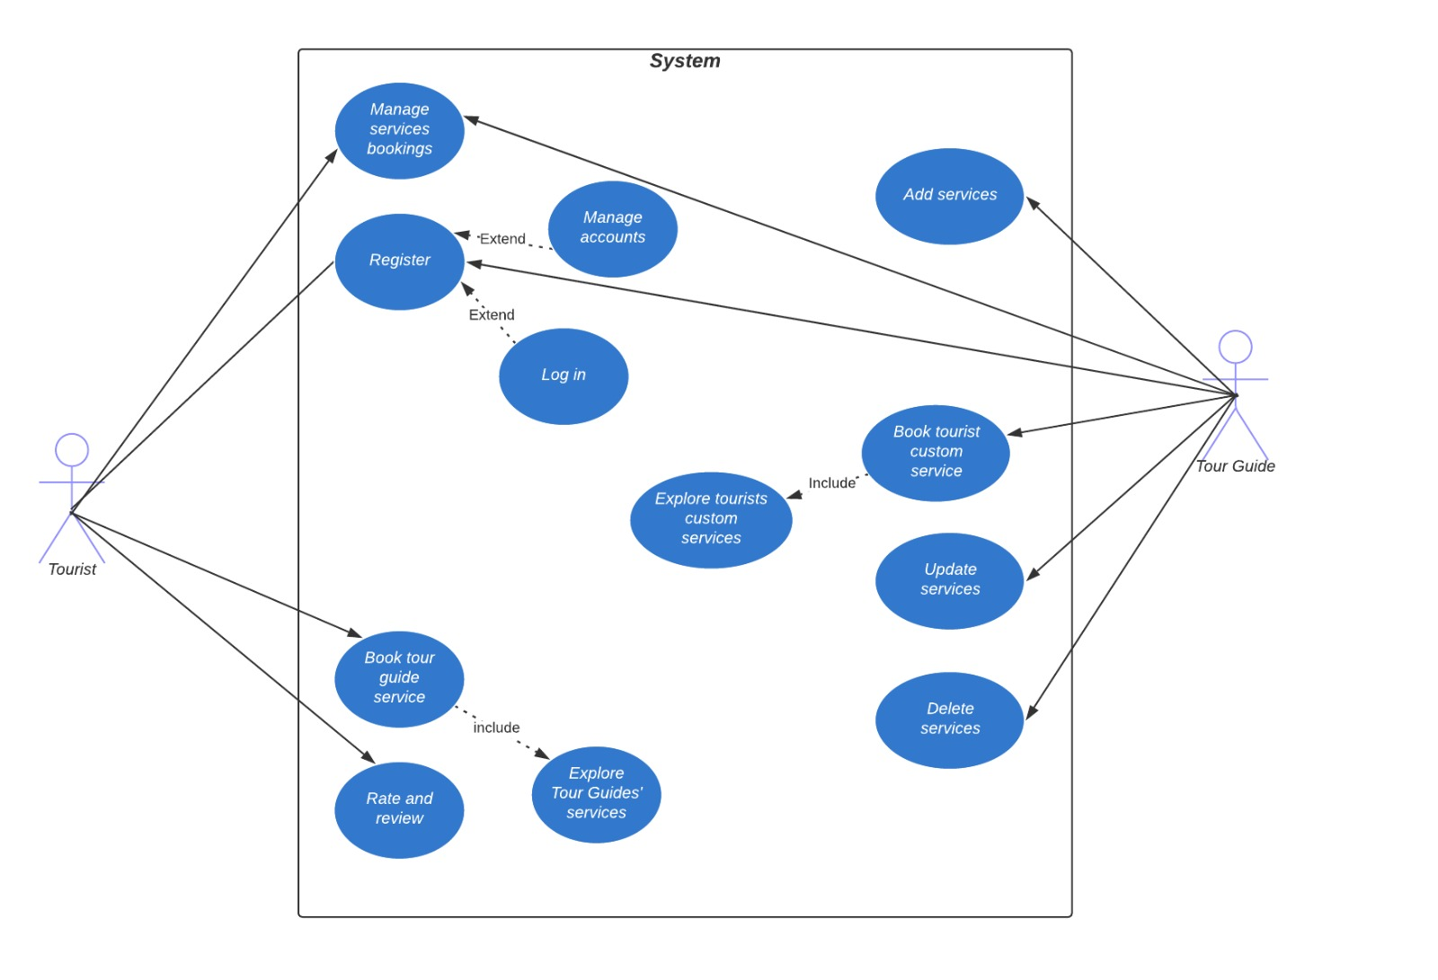

**Use Case Descriptions**

Use Case: Tourist Manage Proposals

|  |  |
| --- | --- |
| Use case name | Tourist Manage Proposals |
| Unique name | Manage Proposals |
| Participating actors | Tourist, Tour Guide |
| Entry conditions | Tourist is logged in and has sent proposals to tour guides. |
| Exit conditions | Tourist reviews and manages the proposals. |
| Special requirements | None |
| Flow of events  “Happy Path” | * Tourist accesses the "Manage Proposals" section. * The system displays the proposals sent by the tourist to tour guides. * Tourist can view the status, details, and responses of each proposal. * Tourist can accept, reject, or negotiate the proposals. * The system updates the status of the proposals based on the tourist's actions. * Tourist can communicate with tour guides to finalize the details. |

Use Case: Register

|  |  |
| --- | --- |
| Use case name | Register |
| Unique name | Register |
| Participating actors | Tourist, Tour Guide |
| Entry conditions | The user accesses the registration page. |
| Exit conditions | The user successfully registers and creates an account. |
| Special requirements | None |
| Flow of events  “Happy Path” | * The user accesses the registration page. * The user enters the required information, such as name, email, and password. * The system validates the information and checks for any existing accounts with the same email. * If the information is valid, the system creates a new account for the user. * The user receives a confirmation or verification email. * The user completes the registration process by verifying the email. |

Use Case: Log In

|  |  |
| --- | --- |
| Use case name | Log In |
| Unique name | Log In |
| Participating actors | Tourist, Tour Guide |
| Entry conditions | The user accesses the login page. |
| Exit conditions | The user successfully logs into their account. |
| Special requirements | None |
| Flow of events  “Happy Path” | * The user accesses the login page. * The user enters their email and password. * The system verifies the entered credentials. * If the credentials are valid, the user is granted access to their account. * The user is redirected to the dashboard or relevant page based on their role (tourist or tour guide). |

Use Case: Manage Accounts

|  |  |
| --- | --- |
| Use case name | Manage Accounts |
| Unique name | Manage Accounts |
| Participating actors | Tourist, Tour Guide |
| Entry conditions | The user is logged into their account. |
| Exit conditions | The user is logged into their account. |
| Special requirements | None |
| Flow of events  “Happy Path” | * The user accesses the account management section. * The system displays the user's account information. * The user can update their personal details, such as name, contact information, or profile picture. * The user can change their account settings, such as notification preferences or password. * The user saves the changes, and the system updates the account information accordingly. |

Use Case: Enter Payment Details

|  |  |
| --- | --- |
| Use case name | Enter Payment Details |
| Unique name | Enter Payment Details |
| Participating actors | Tourist, Tour Guide |
| Entry conditions | The user wants to provide payment information for booking or receiving payments. |
| Exit conditions | The user successfully enters their payment details. |
| Special requirements | None |
| Flow of events  “Happy Path” | * The user accesses the payment details section. * The system presents a form for the user to enter their payment information, such as credit card details or digital payment account. * The user fills in the required fields with accurate payment information. * The system validates the entered payment details. * If the details are valid, the user's payment information is saved securely in the system. |

Use Case: Tourist Send Proposal to Tour Guide Service

|  |  |
| --- | --- |
| Use case name | Tourist Send Proposal to Tour Guide Service |
| Unique name | Send proposal |
| Participating actors | Tourist |
| Entry conditions | The tourist has explored tour guide services and identified a preferred service. |
| Exit conditions | The proposal is successfully sent to the tour guide. |
| Special requirements | None |
| Flow of events  “Happy Path” | * The tourist selects a tour guide service of interest. * The tourist clicks on the "Send Proposal" button or similar action. * The system presents a form for the tourist to enter the proposal details, including desired price or any specific requirements. * The tourist fills in the proposal form and submits it. * The system sends the proposal to the respective tour guide. * The system notifies the tourist about the successful submission of the proposal. |

Use Case: Book Tour Guide Service

|  |  |
| --- | --- |
| Use case name | Book Tour Guide Service |
| Unique name | Book/Confirm a service |
| Participating actors | Tourist |
| Entry conditions | The tourist has received an accepted proposal from a tour guide. |
| Exit conditions | The tourist successfully books the tour guide service. |
| Special requirements | None |
| Flow of events  “Happy Path” | * The tourist reviews the accepted proposal from the tour guide. * The tourist confirms their decision to book the service. * The system prompts the tourist to provide additional details, such as the preferred date and duration of the service. * The tourist fills in the required information and submits the booking request. * The system confirms the booking and notifies both the tourist and tour guide about the successful reservation. |

Use Case: Explore Tour Guide Services

|  |  |
| --- | --- |
| Use case name | Explore Tour Guide Services |
| Unique name | Explore services |
| Participating actors | Tourist |
| Entry conditions | The tourist accesses the explore section of the platform. |
| Exit conditions | The tourist finds suitable tour guide services. |
| Special requirements | None |
| Flow of events  “Happy Path” | * The tourist accesses the explore section of the platform. * The system displays a list of available tour guide services, including information about each service and tour guide. * The tourist can filter or search for specific services based on location, ratings, or other criteria. * The tourist selects a service to view detailed information about the tour guide, service offerings, and reviews. * The tourist repeats the process to explore other services until they find a suitable option. |

Use Case: Rate and Review

|  |  |
| --- | --- |
| Use case name | Rate and Review |
| Unique name | Rate and Review |
| Participating actors | Tourist |
| Entry conditions | The tourist has completed a tour guide service. |
| Exit conditions | The tourist successfully rates and reviews the tour guide service. |
| Special requirements | None |
| Flow of events  “Happy Path” | * After the tour guide service is completed, the system prompts the tourist to provide a rating and review. * The tourist rates the service based on their experience, usually using a numerical scale or star rating. * The tourist can provide additional comments or feedback in the review section. * The system saves the rating and review for the respective tour guide and displays it on their profile or service page. |

Use Case: Add Service for the Tour Guide

|  |  |
| --- | --- |
| Use case name | Add Service for the Tour Guide |
| Unique name | Add Service |
| Participating actors | Tour Guide |
| Entry conditions | The tour guide wants to add a new service to their profile. |
| Exit conditions | The new service is successfully added to the tour guide's profile. |
| Special requirements | None |
| Flow of events  “Happy Path” | * The tour guide accesses the "Add Service" section in their account. * The system presents a form for the tour guide to enter the details of the new service, such as service description, duration, price, and availability. * The tour guide fills in the required information and submits the form. * The system validates the entered information and adds the new service to the tour guide's profile. * The system notifies the tour guide about the successful addition of the service. |

Use Case: Update Service for the Tour Guide

|  |  |
| --- | --- |
| Use case name | Update Service for the Tour Guide |
| Unique name | Update Service |
| Participating actors | Tour Guide |
| Entry conditions | The tour guide wants to modify an existing service in their profile. |
| Exit conditions | The service is successfully updated with the new information. |
| Special requirements | None |
| Flow of events  “Happy Path” | * The tour guide accesses the "Manage Services" section in their account. * The system displays a list of their existing services. * The tour guide selects the service they want to update. * The system presents a form populated with the current information of the selected service. * The tour guide makes the necessary changes to the service details, such as description, duration, price, or availability. * The tour guide submits the updated information. * The system validates the changes and updates the service with the new information. |

Use Case: Delete Service for the Tour Guide

|  |  |
| --- | --- |
| Use case name | Delete Service for the Tour Guide |
| Unique name | Delete Service |
| Participating actors | Tour Guide |
| Entry conditions | The tour guide wants to remove an existing service from their profile. |
| Exit conditions | The service is successfully deleted from the tour guide's profile. |
| Special requirements | None |
| Flow of events  “Happy Path” | * The tour guide accesses the "Manage Services" section in their account. * The system displays a list of their existing services. * The tour guide selects the service they want to delete. * The system prompts the tour guide for confirmation to delete the selected service. * The tour guide confirms the deletion. * The system removes the service from the tour guide's profile and notifies them about the successful deletion. |

**5. USER EXPERIENCE WIREFRAMES**

Initial prototype screens to validate initial understanding of the product.

**6. PROJECT ORGANIZATION**

1 - Requirement Gathering and Analysis (1 week):

* Define project scope and objectives
* Identify user requirements
* Analyze existing systems and platforms

2 - System Design and Architecture (1 week):

* Design the overall system architecture
* Define the database structure
* Determine the technologies and frameworks to be used

3 - User Interface Design (1 week):

* Create wireframes and mockups for the user interface
* Design the layout, navigation, and visual elements

4 - Development (4 weeks):

* Implement the front-end and back-end functionalities
* Integrate the database and third-party services
* Perform rigorous testing and bug fixing

5 - Deployment and Testing (1 week):

* Deploy the application to the desired platform
* Conduct comprehensive testing to ensure functionality and performance
* Address any issues or bugs found during testing

6 - User Acceptance Testing (1 week):

* Invite users to test the application and provide feedback
* Make necessary improvements based on user feedback

7 - Documentation and Training (1 week):

* Prepare user manuals and documentation
* Conduct training sessions for users and administrators

8 - Launch and Maintenance (Ongoing):

* Launch the application for public use
* Monitor and maintain the application's performance and security
* Release updates and enhancements based on user feedback and evolving needs

**Matrix of Responsibilities**

|  |  |  |  |  |  |
| --- | --- | --- | --- | --- | --- |
| **Task/Res** | **Bahaa** | **Ahmed** | **Moustafa** | **Youssef** | **Arwa** |
| Requirement gathering and analysis | **T** |  |  |  |  |
| Designing the user interface |  |  | **T** |  |  |
| Front-end development |  | **T** |  |  | **T** |
| Back-end development |  | **T** |  |  |  |
| Database design and implementation |  |  |  | **T** |  |
| Testing and quality assurance | **T** | **T** | **T** | **T** | **T** |
| Communication and coordination | **T** | **T** | **T** | **T** | **T** |

**PERT / Gantt Chart**

First cut at schedule

**7. VALIDATION PLAN**

**Test Strategy**

**Definition of Done:**

* The definition of done represents the criteria that must be met for a specific work item or deliverable to be considered complete. It ensures that each task or feature has been thoroughly tested, meets the specified requirements, and is ready for deployment. The definition of done may include the following criteria:

1. All code is implemented and reviewed.
2. Unit tests are written and passed successfully.
3. Integration tests are executed and passed.
4. Acceptance criteria defined in user stories or use cases are met.
5. Functional requirements are implemented and tested.
6. Performance and security requirements are validated.
7. Documentation is complete and up to date.
8. All identified defects are resolved, and regression testing is performed.
9. Stakeholder review and approval have been obtained.

**Success Criteria:**

* The success criteria define the desired outcomes and goals that indicate a successful testing and validation process. The success criteria for my project may include the following aspects:

1. All test cases have been executed, and the expected results have been obtained.
2. Defects and issues identified during testing have been addressed and resolved.
3. The system performs efficiently and meets the specified performance benchmarks.
4. The application functions correctly and meets the defined functional requirements.
5. User acceptance testing has been conducted, and the application is approved by stakeholders.
6. The project is delivered on time, within budget, and meets the quality standards.
7. The system is ready for deployment and use by end-users.
8. User feedback and satisfaction are positive.
9. The project has met the defined objectives and fulfilled the requirements.

**8. FEASIBILITY STUDY**

1. **Technical Risks:**

* Risk: Compatibility issues between different platforms and devices.

Handling: Conduct thorough compatibility testing across various platforms and devices to identify and resolve any compatibility issues early in the development process.

* Risk: Integration challenges with third-party services or APIs.

Handling: Conduct integration testing with the third-party services or APIs during development to ensure smooth integration. Maintain communication channels with the service providers to address any integration-related issues promptly.

1. **Security Risks:**

* Risk: Data breaches or unauthorized access to user information.

Handling: Implement strong security measures such as encryption, secure authentication, and secure data storage to protect user data. Regularly conduct security audits and penetration testing to identify and address any vulnerabilities.

* Risk: Inadequate protection against common security threats (e.g., cross-site scripting, SQL injection).

Handling: Follow secure coding practices, conduct security reviews, and implement security controls and validation mechanisms to mitigate common security threats.

1. **Operational Risks:**

* Risk: Server or infrastructure failures.

Handling: Implement redundancy and backup mechanisms to ensure high availability and quick recovery in case of failures. Regularly monitor the server and infrastructure performance to identify potential issues.

* Risk: Inadequate scalability to handle increased user load.

Handling: Perform load testing to identify performance bottlenecks and scalability limitations. Optimize the system architecture and infrastructure to handle increased user loads.

1. **Project Management Risks:**

* Risk: Delays in development or scope creep.

Handling: Implement effective project management practices such as regular progress tracking, agile development methodologies, and frequent communication to manage scope and minimize delays.

* Risk: Resource constraints or team member turnover.

Handling: Maintain a skilled and dedicated development team. Anticipate resource constraints and plan for contingencies, such as resource allocation adjustments or knowledge transfer processes in case of team member turnover.

1. **User Adoption and Satisfaction Risks:**

* Risk: Low user adoption or engagement.

Handling: Conduct user research, gather feedback, and iterate based on user needs and preferences. Implement user-friendly interfaces, intuitive workflows, and engaging features to enhance user adoption and satisfaction.

* Risk: Negative user feedback or low ratings.

Handling: Implement a feedback mechanism to gather user input and address issues promptly. Continuously monitor user reviews and ratings, and take proactive steps to resolve user concerns and improve the user experience.

**Risk Prioritization**

1. Data breaches or unauthorized access to user information
2. Compatibility issues between different platforms and devices
3. Delays in development or scope creep
4. Inadequate protection against common security threats
5. Integration challenges with third-party services or APIs
6. Server or infrastructure failures
7. Low user adoption or engagement
8. Inadequate scalability to handle increased user load
9. Negative user feedback or low ratings
10. Resource constraints or team member turnover

**Risk Mitigation**

1. Risk factors will be addressed through a proactive risk management approach. The following steps will be taken:
2. Risk Identification: Continuously identify potential risks that may arise during the project. This will be done through regular risk assessments, stakeholder inputs, and lessons learned from similar projects.
3. Risk Analysis: Assess the impact and likelihood of each identified risk to prioritize them based on their significance. This analysis will help in understanding the potential consequences of each risk and determining the appropriate response.
4. Risk Mitigation: Develop and implement risk mitigation strategies to reduce the probability or impact of identified risks. This may include implementing preventive measures, contingency plans, or risk transfer mechanisms.
5. Risk Monitoring: Regularly monitor and track the identified risks throughout the project lifecycle. This includes monitoring the effectiveness of implemented mitigation measures and identifying any new risks that may arise.
6. Risk Response: Promptly respond to any identified risks by executing the planned mitigation strategies. This may involve activating contingency plans, allocating additional resources, or revising project plans as necessary.
7. By when: Risk management is an ongoing process that should be carried out throughout the project duration. It should start at the early stages of the project and continue until project completion. Regular risk assessments and updates should be conducted to address any new risks that may arise and ensure effective risk management throughout the project lifecycle.

**9. CONFIGURATION AND VERSION CONTROL**

**Process:**

1. Version Control System Selection (VCS): Choose a suitable VCS such as Git, which is widely used and provides robust features for version control.
2. Initialize Repository: Create a new repository for my project using the chosen VCS. This will serve as the central repository for storing and managing your project artifacts.
3. Define Branching Strategy: Decide on a branching strategy that fits your project's development workflow. Common strategies include a main branch (e.g., master or main), feature branches, release branches, and hotfix branches.
4. Branch Creation: Create branches for different features, bug fixes, or releases based on the branching strategy. Each branch represents a separate line of development.
5. Commit Changes: Regularly commit your changes to the repository. Each commit should represent a logical unit of work and have a clear and concise commit message describing the changes made.
6. Pull Requests (PRs): For collaborative development, utilize pull requests to review and merge code changes. When a feature or bug fix is complete in a branch, create a PR to merge it into the main branch. Reviewers can provide feedback, and the changes can be further refined before merging.
7. Continuous Integration (CI) Integration: Connect your version control system with a CI service (e.g., Jenkins, CircleCI) to automate the build, test, and deployment processes. CI can trigger builds and tests whenever changes are pushed to the repository, ensuring that the codebase remains in a working state.

**Attributes:**

1. Version Tagging: Use tags or labels to mark significant versions or milestones of your project, such as releases or specific points in the codebase's history.
2. Change History: Maintain a comprehensive log of commits and changes made to the project, providing a clear record of who made the changes and why.
3. File and Directory Structure: Organizing my project artifacts in a structured manner, ensuring consistent naming conventions and logical directory hierarchies for easy navigation and maintenance.
4. Documentation: Include relevant documentation within the repository, such as README files, user guides, and API documentation. Keep the documentation updated and versioned alongside the codebase.
5. Merge Conflict Resolution: When merging branches, be prepared to resolve any conflicts that arise due to overlapping changes. Carefully review conflicting sections and resolve conflicts to maintain a cohesive codebase.
6. Code Review Checklist: Establish a code review checklist or guidelines to ensure that reviews are thorough and cover important aspects like code quality, performance, security, and adherence to coding standards.
7. Backup and Recovery: Regularly back up the repository to prevent data loss in case of hardware failures or other incidents. Consider implementing off-site backups or replication for added resilience.

**10. TOOLS**

1. Flutter: A framework for building cross-platform mobile applications. It provides a set of tools and libraries for developing user interfaces, managing state, and accessing device features.
2. Integrated Development Environment (IDE): Such as Visual Studio Code or Android Studio with the Flutter and Dart plugins for writing, debugging, and testing your Flutter code.
3. Version Control System (VCS): like Git or Subversion can be used to track changes in your project's source code, collaborate with team members, and manage different versions of your codebase.
4. Firebase: A comprehensive suite of cloud-based tools and services provided by Google. Firebase can be used for various purposes in your project, including authentication, real-time database, cloud storage, and cloud messaging.
5. Payment Gateway: I will need to integrate with a payment gateway service such as PayPal, Stripe, or Braintree. These services provide APIs and SDKs for handling payment transactions securely.
6. Communication and Collaboration Tools: To facilitate team collaboration, tools like Slack, Microsoft Teams, or Trello can be used for communication, task management, and project coordination.
7. Testing Frameworks: For automated testing of my application, you can utilize testing frameworks like Flutter's built-in testing framework, as well as additional tools like Flutter Driver or Mockito for integration testing and mocking dependencies.
8. Analytics and Monitoring Tools: Services like Google Analytics, Firebase Analytics, or Crashlytics can provide insights into user behavior, app performance, and crash reporting, enabling you to make data-driven decisions and track the health of your application.

**11. ARCHITECTURE**

1. Mobile Devices: As my project involves a mobile application developed using Flutter, I would need mobile devices such as smartphones or tablets to run and test the application. These devices should be compatible with the Flutter framework and meet the minimum system requirements
2. Server Infrastructure: My project may require a server infrastructure to host the backend services and databases. This could include physical servers, virtual machines, or cloud-based hosting solutions like Amazon Web Services (AWS) or Google Cloud Platform (GCP).
3. Database Server: For storing and managing the project's data, I would need a database server. Depending on your requirements, you could choose a relational database management system (such as MySQL or PostgreSQL) or a NoSQL database (such as MongoDB or Firebase Firestore).
4. Payment Gateway Integration: My project involves accepting online payments from tourists, I need to integrate with a payment gateway service. This would require setting up the necessary configurations and establishing secure connections with the payment gateway provider.
5. GPS Tracking Devices: My project involves GPS-based functionalities, such as tracking the location of tourists or providing navigation services, I require GPS tracking devices. These could be integrated with the mobile application or accessed via external APIs.
6. Communication Infrastructure: To facilitate communication between tourists and tour guides, I need communication subsystems such as messaging APIs, real-time chat functionality, or video conferencing solutions. These would enable seamless communication between users within the application.
7. Analytics and Monitoring Tools: I may consider incorporating analytics and monitoring tools to gather insights, track user behavior, monitor system performance, and ensure the overall health of your application.